Economy, Transport and Environment Department

Elizabeth II Court West, The Castle

Winchester, Hampshire SO23 8UD

Tel: 0300 555 1388 (Roads and Transport)

www.hants.gov.uk/transport

Enquiries to | James Laver | My reference R.J508197.01
Direct Line | 0300 555 1388 | Your reference
Date | 25 June 2021 | Email: saferplaces@hants.gov.uk

Dear Resident/Business Manager

School Streets Trial: Temporary access restrictions for non-essential vehicles at Harrison Road, Fareham

I am pleased to let you know that the road outside Harrison Primary School is going to become quieter and less busy at school drop-off and pick-up times. Hampshire County Council is planning a trial ‘School Streets’ initiative on Harrison Road, to introduce timed restrictions on the use of motor vehicles during the start and end of the school day. This will allow children to walk, scoot or cycle to school in what will generally be a car-free environment.
A temporary restriction on vehicle access will be introduced on the full length of Harrison Road (see below) between 8:15-9:00am and 2.45-3.30pm. During these periods, trained School Streets stewards in high-visibility vests will place barriers on the road to restrict access for non-essential vehicles. The School Street will not operate during school holidays, INSET days or at weekends.
These temporary restrictions will not apply to residential/business premises within the affected area of the street, emergency services, blue badge holders, deliveries and carers of residents on the street. Any driver needing to enter or exit the street will be asked to drive at walking pace and may be escorted if appropriate. We would ask that you try to avoid driving through the school street zone during these times where possible and avoid scheduling deliveries for these periods. If access is required during these periods, please try to enter/exit from the Serpentine Road end of the road to avoid driving past the main school entrance. All existing parking restrictions will operate as normal.
The School Street trial will commence on 19 July 2021 and will be in effect until at least the end of October, at which time a decision will be made on whether to continue the trial for a longer duration.
A list of common FAQs regarding the operation of the restrictions is enclosed and further information is available at myjourneyhampshire.com/hants-school-streets.

If you like the idea of a car-free school street, perhaps you will consider becoming a volunteer steward. Stewards help to manage traffic at the barriers and ensure that children are safe at pick up and drop off times. If you are available on any days at drop-off / pick-up times and are keen to be part of our School Street community, then do get in touch with the school. Full training will be provided.

We hope that you will be supportive of this project. We value your feedback and welcome any comments you would like to make regarding the trial. There will be opportunities for you to give feedback throughout the trial period. If you have any questions or comments about the School Street, please get in touch by emailing saferplaces@hants.gov.uk or use the contact details above.

Yours faithfully,

James Laver
Client Manager
Hampshire County Council Strategic Transport

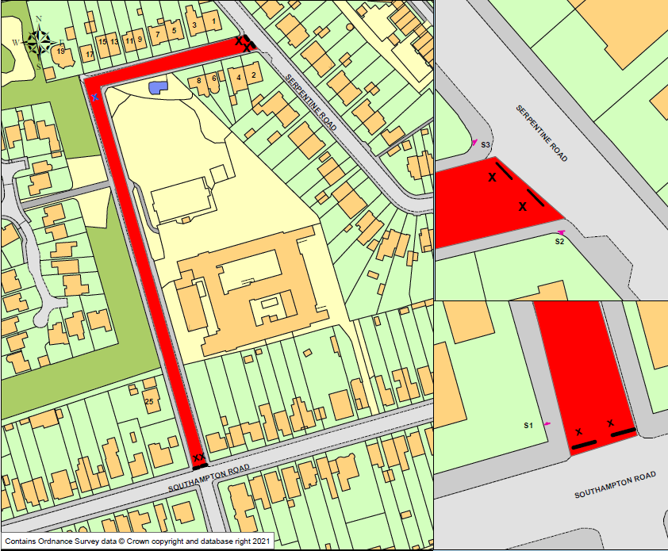
School Street Closure Zone, Harrison Primary School

