Dear Parent/Guardian,

School Streets Trial Project

Cadland Primary School is pleased to announce that we will be taking part in a School Streets trial, in partnership with Hampshire County Council and the charity Sustrans. A ‘School Street’ is a road closure outside the school at the beginning and the end of the school day, intended to make the area outside our school gate a healthier and more pleasant environment and to make it easier for everyone to travel actively and safely.
A temporary restriction on vehicle access will be introduced on the full length of the School Access Road and Mary Drake Close (see below) between 8:15-9:00am and 2.30-3.15pm. During these periods (on school days only), trained School Streets stewards in high-visibility vests will place barriers on the road to restrict access for non-essential vehicles. The access restrictions will not apply to residential/business premises within the affected street, school staff, emergency services, blue badge holders, deliveries and carers of residents on the street. However, they will apply to all general school-related drop-off and pick-up traffic.
The School Streets trial will commence on 16 July 2021 and will be in effect until at least the end of October, at which time a decision will be made on whether to continue the trial for a longer duration.

Important safety information during the School Street
- Please support the trial by walking, cycling or scooting to and from school.

- If you do need to use a car, please park away from the school, perhaps using one of our designated Park and Stride sites [include link to map?]. It is important to be mindful of local residents by not obstructing driveways and public transport routes. Any parking restrictions will operate as normal.
- Some permitted vehicles will still be present within the School Street. These drivers will be advised by stewards at the barriers to drive at walking pace through the restricted area and may be escorted by a steward.

- Parents/carers remain responsible for their children at all times on the journey to and from the school site.

Request for Volunteers
If you like the idea of a car-free school street, perhaps you will consider becoming a volunteer steward. Stewards help to manage traffic at the barriers and ensure that children are safe at pick up and drop off times. If you are available on any days at drop-off / pick-up times and are keen to be part of our School Street community, then do get in touch. Full training will be provided.
We are really excited about this opportunity and encourage you to provide feedback as the project evolves. A list of common FAQs regarding the operation of the School Street is enclosed and further information is available at myjourneyhampshire.com/hants-school-streets. If you have any immediate questions or comments, please contact the school or email saferplaces@hants.gov.uk.

There is further information on how you can make a difference on the journey to school on the My Journey Hampshire website www.myjourneyhampshire.com/education [and school link?]

Best wishes

James Nutbeam
Headteacher

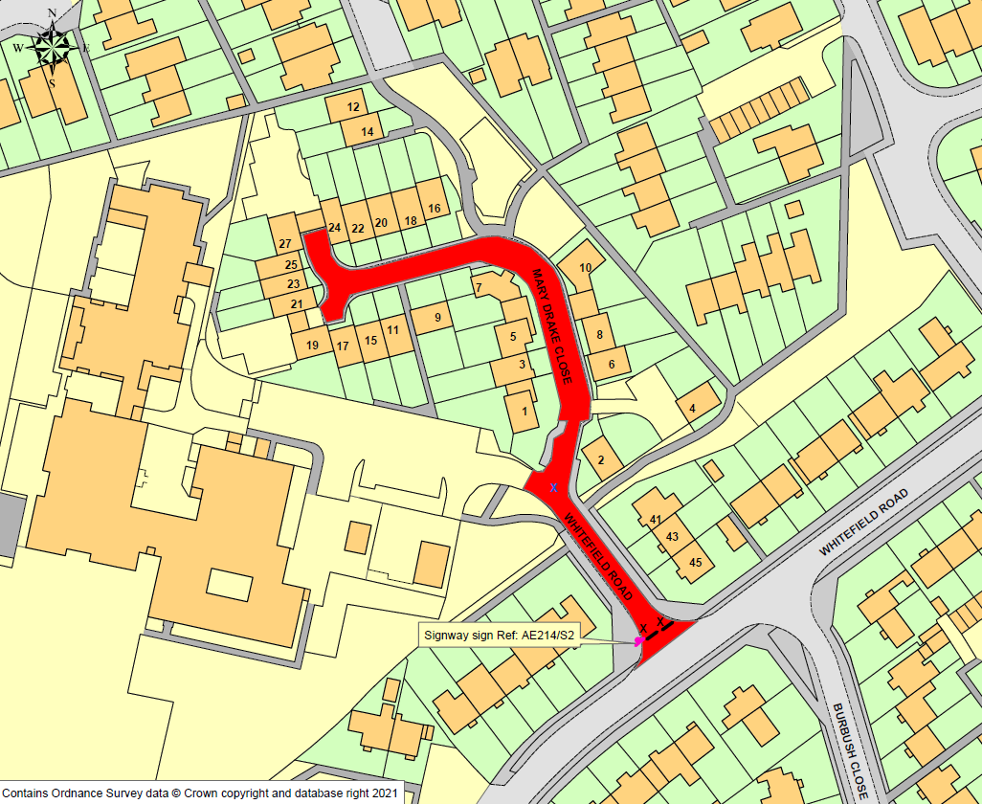
School Street Closure Zone, Cadland Primary School

